**Excel Assignment – 9**

**1. What are the different margins options and do we adjust the margins of the excel worksheet?**

In Excel, page margins are used to specify how much *white space* (blank area) should be left around the information in your worksheet. This is very similar to how margins are conceived and used in other programs, such as a word processor. Margins are used to provide a visual border for your printed page and an area where the page can be held or bound.

To set margins for a worksheet, choose Page Setup from the File menu. Excel displays the Page Setup dialog box; you should make sure the Margins tab is selected.

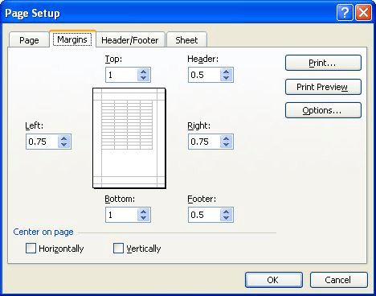

There are four margins you can specify: top, bottom, left, and right. Each margin refers to the distance from the edge of the paper to where the information in your worksheet can be printed. Thus, a one-inch top margin means there will be one inch of white space at the top of each page of your printout.

**2. Set a background for your table created.**

In Microsoft Excel, you can use a picture as a sheet background for display purposes only. A sheet background is not printed, and it is not retained in an individual worksheet or in an item that you save as a Web page.

Add a sheet background

1. Click the worksheet that you want to display with a sheet background. Make sure that only one worksheet is selected.
2. On the **Page Layout** tab, in the **Page Setup** group, click **Background**.

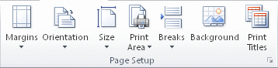

1. Select the picture that you want to use for the sheet background, and then click **Insert**.

The selected picture is repeated to fill the sheet.

* To improve readability, you can hide cell gridlines and apply solid color shading to cells that contain data.
* A sheet background is saved with the worksheet data when you save the workbook.

**3. What is freeze panes and why do we use freeze panes? Give examples.**

Freeze Panes is a useful tool located in View Bar. In larger sheets, we have the data headers in the top rows and first columns. And on scrolling down or to the right, these headers do not appear.

The Excel Freeze Panes tool allows us to freeze the column/row or multiple columns/rows headings so that when we scroll down or move to the right to view the rest of the sheet, the rows/columns are that are frozen remain on the screen. After freezing, below that row and column, a grey line appears to make the partition.

To freeze rows:

Select the **row**below the row(s) you want to **freeze**. example, we want to freeze rows **1** and**2**, so we'll select row**3**.

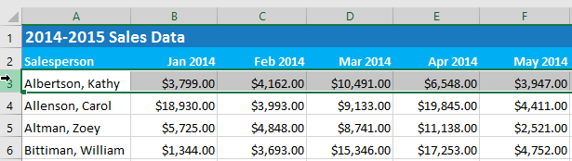

On the **View** tab, select the **Freeze Panes** command, then choose **Freeze Panes** from the drop-down menu.

The rows will be **frozen** in place, as indicated by the **gray** **line**. You can **scroll down** the worksheet while continuing to view the frozen rows at the top. In example, we've scrolled down to row **18**.

**4. What are the different features available within the Freeze Panes command?**

Excel enables three methods to freeze the pane.

1. Freeze Pane
2. Freeze Top Row
3. Freeze First Column

Freeze Pane

When you freeze a part of the Excel worksheet using this freeze pane option, it keeps the rows and columns visible, scrolling is available through rest of the worksheet. This one allows the user to freeze the worksheet wherever he/she want. It freezes both rows and columns of the worksheet.

Freeze Top Row

When you freeze the top row of your Excel worksheet using this freeze pane option, the first row of the Excel worksheet freezes and visible through the entire scrolling of the worksheet vertically.

Remember - in this method, only the first row is visible to the users after freezing through the entire worksheet scrolling. Steps are almost similar to the above method.

Freeze First Column

When you freeze the first column of your Excel worksheet using this freeze pane option, the first column freezes at its place and is visible through the entire scrolling of the worksheet horizontally.

After freezing the first column of the worksheet, this column is available through horizontal scrolling. Steps are almost the same as the Freeze top row method.

**5. Explain what the different sheet options present in excel are and what they do?**

Since an Excel sheet is one of the core elements of the workbook, there are multiple core options to perform from the Sheet Options. We can access various sheet options by using the following ways:

* Ribbon Sheet Options
* Right-click Sheet Options

Ribbon Sheet options

Excel has all the basic and advanced options present on its ribbon. Likewise, some quick sheet options are also present on the Excel ribbon and can be accessed by going to **Page Layout > Sheet Options.** It mainly has four toggle options: two for **Gridlines** and two for **Headings,** and they can be turned on and off by selecting and deselecting the checkboxes.

* **Gridlines:**
  + **View:** This option allows users to show/ hide gridlines within the active worksheet. Turning off this option removes the gridlines from the sheet and displays a blank Excel sheet.
  + **Print:** This option allows users to show/ hide gridlines on an Excel document that will be printed on paper.
* **Headings:**
  + **View:** This option allows users to show/ hide headings within the active worksheet. Turning off this option removes the headings from the current sheet's headers and footers.
  + **Print:** This option allows users to show/ hide headings on an Excel document, which is to be printed on paper.

Right Click sheet Options

In Excel, the right-click with mouse button usually displays the context menu for the selected element. When we press the right-click on any Sheet tabs, Excel displays a list of options relevant to Excel sheets. The list includes various sheet options. However, this list is usually called the 'worksheet menu'

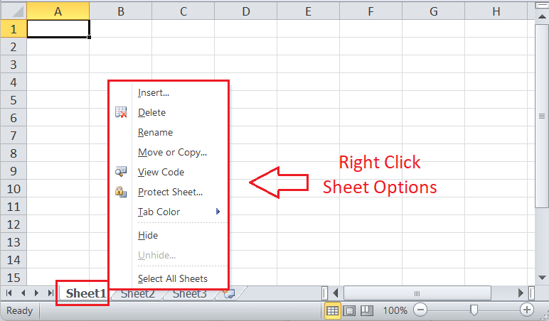

Here we can insert, delete, rename or copy the sheets. Also we can use protect sheet feature.